1. **Vancomycin Therapeutic Drug Monitoring Update**
2. The old vancomycin trough of 15-20 mg/dL surrogate goal is outdated and linked to 30% increase in development of acute kidney injury (AKI)
3. Under most circumstances, we can consider MRSA infections to have a minimum inhibitory concentration (MIC) = 1 mg/L (unless the MIC is known and above 1 by broth microdilution or other method verified for accuracy) review of literature has identified no evidence of MIC creep phenomenon.
4. Transitioning to 24 hour area under the curve (AUC24)/MIC with a goal of 400-600 via direct PK/PD monitoring is a more accurate predictor of clinical efficacy
5. **Indications for AUC24/MIC** **monitoring:**

Invasive **MRSA infections,** including:

* 1. Bacteremia
  2. Pneumonia
  3. Meningitis
  4. Endocarditis
  5. Osteomyelitis

1. **EXCLUSIONS for AUC24/MIC** **dosing**:
   1. Skin and soft tissue infections (ABSSSI): 10 – 15 mg/dL trough target efficacious
   2. Enterococcal infections: 10 – 15 mg/dL trough target efficacious
   3. *Staphylococcus epidermidis* infections: 10 – 15 mg/dL
   4. Urinary tract infections
   5. Acute kidney injury/Rapidly changing renal function
   6. ERSD on Hemodialysis or Peritoneal Dialysis *(Chronic kidney disease, but stable residual renal function, should get AUC based dosing)*
   7. Surgical prophylaxis
2. **Dosing:**
   1. Loading doses (20-35 mg/kg Actual Body Weight (ABW) up to 3000 mg based on patient population) for:
      1. All ED patients will get loading dose due to uncertainty of critical illness
      2. Critically ill or ICU patients
      3. Documented serious MRSA infections
      4. Hemodialysis, Peritoneal Dialysis or CRRT Patients
      5. Obese pediatric patients
   2. Maintenance doses will be based on empiric dosing calculator population estimates (maximum 4500 mg/day). In the calculator, any doses > 4500 mg/day will appear in red.
   3. Hemodialysis: 20 - 25 mg/kg ABW loading dose followed by 7.5 – 10 mg/kg maintenance dose after hemodialysis
   4. Continuous Renal Replacement (effluent rates 20 – 25 mg/kg/h): 20 - 25 mg/kg ABW loading dose followed by 7.5 – 10 mg/kg maintenance dose every 12 hours CVVHD, every 24 hours for CVVH; consideration should be given to the lowering Vd as fluid overload resolves (Nebraska Renal Dosing Guidelines)
   5. Peritoneal Dialysis: 20 – 25 mg/kg IV or IP loading dose, followed by 7.5 – 10 mg/kg IV or IP Q48-72hrs based on serum levels
3. **Post Dose Levels:**

* Two post dose levels are utilized to calculate AUC24/MIC ratio 🡪 should be ordered as Peak and Trough levels
* Priority for measuring levels:

1. Measuring levels after the first dose is recommended for:
   1. Severe infection (Bacteremia, meningitis)
   2. High risk for AKI (ICU residence, CKD, concurrent nephrotoxin exposure)
   3. Obese - BMI ≥ 30 kg/m2
   4. Large empiric maintenance doses
      1. Adults ≥ 4000 mg/day
      2. Pediatrics ≥ 2500 mg/day
   5. Continuous renal replacement (CRRT)
2. All other levels should be measured at or close to steady state, typically after the 4th dose

* Level order timing; order two (2) random vancomycin levels at least one (1) estimated half-live (t1/2) apart.
  + - First level - schedule at least one (1) hour after the end of the first dose infusion to allow for proper distribution.
    - Second level - should be at end of the dosing interval, before the next dose.
    - The dosing frequency of vancomycin may make it difficult to schedule two post levels at least 1 t ½, apart (i.e. extended infusion time, short t ½, short dosing interval), the levels may need to be drawn at shorter than one t ½ interval.
    - Ensure line where vancomycin was infusing is properly flushed prior to level collection to prevent falsely elevated levels.
* Hemodialysis: maintaining pre-dialysis concentrations between 15 and 20 mg/L is likely to achieve the AUC24/MIC of 400 to 600 mg·h/L in the previous 24 hours; pre-dialysis level preferred, may be drawn 4 hours after the end of hemodialysis prior to next dose if pre-dialysis window is missed.
* Continuous Renal Replacement Therapy (CRRT) – Monitor random level in first 24 hours with goal of 15 – 20 mg/L to ensure AUC24/MIC targets are met
* Peritoneal Dialysis – monitor one random level every 2 - 3 days as needed, re-dose when serum levels fall below 15 mcg/mL (ISPD Guidelines)

1. **Monitoring Frequency:**
2. Hemodynamically stable, await culture results. If vancomycin is to be continued, initial steady state monitoring and then weekly monitoring is sufficient.
3. Hemodynamically unstable or at higher risk of nephrotoxicity (critically ill, concurrent nephrotoxins), more frequent monitoring recommended
4. Hemodialysis: predialysis serum concentration monitoring should be performed weekly
5. Peritoneal dialysis: serum concentration monitoring should be performed weekly once clearance rate identified\
6. CRRT: daily evaluation of modality and ultrafiltration rate to guide level monitoring
7. **Vancomycin Time Out at 24 – 48 Hours Checklist**

The following questions should be considered prior to continuing antibiotic therapy.

1. Is a bacterial infection present? Yes  No If No, vancomycin should be discontinued.
2. Has the site of infection been determined?  No  Yes If Yes, select one:

Deep-seated endovascular infection (e.g., S. aureus bacteremia, endocarditis, meningitis, osteomyelitis, necrotizing fasciitis, mediastinitis, epidural or visceral abscess)

Diabetic foot infection

Intra-abdominal infection

IV catheter related bloodstream infection

Pneumonia

Sepsis

Skin/soft tissue infection (non-surgical site related)

Surgical site or device/prosthesis-related infection

Urinary tract infection

Other ________________________________________________

1. Has an infectious disease physician recommended continuation of vancomycin?

Yes - continue vancomycin

No

1. Has the culprit bacterial pathogen(s) been identified?

Yes, definitively known – therapy is for an infection known to be caused by a culture proven gram positive organism - continue vancomycin until at least susceptibilities are known.

Yes, definitively known – therapy is for an infection known to be caused by a culture proven gram positive organism susceptible only to vancomycin or patient has a serious beta-lactam allergy – continue vancomycin, determine length of therapy.

Yes, definitively known – therapy is for an infection known to be caused by a culture proven gram positive organism susceptible to beta-lactam antibiotics. Recommend vancomycin discontinuation - vancomycin may be less rapidly bactericidal than beta-lactam agents for methicillin-susceptible staphylococci (MSSA).

Possibly, a gram positive pathogen is suspected (microbiological results are pending) – follow-up in 48 hours.

1. **Has the patient had a positive MRSA nasal surveillance culture or PCR within 24 hours of starting vancomycin?  Yes  No - Negative MRSA surveillance cultures have a 99% negative** **predictive value of MRSA HCAP.**
2. Is the patient clinically stable?  No  Yes - if Yes can the patient be switched to an oral antibiotic?
3. **Oral De-escalation Options According to Underlying Infection*:**

|  |  |  |
| --- | --- | --- |
| **Infection** | **MRSA COVERAGE WARRANTED** | **MRSA COVERAGE NOT WARRANTED** |
| **Skin and soft tissue infection** (suspect MRSA if induration, fluctuance, or purulence is present; diffuse cellulitis suggests a streptococcal etiology) | * TMP-SMZ 2 DS Tab q12h * Clindamycin 450 mg q8h * Doxy/minocycline 100 mg q12h * Linezolid 600 mg q12h | * Dicloxacillin 500 mg q6h * Cephalexin 500 mg q6h |
| **Diabetic foot infection**  (suspect MRSA if prior history of infection or colonization with MRSA) | Mild to moderate infection:   * Cephalexin 1000 mg TID **OR** * Amoxicillin-clavulanate 875/125 mg q12h **OR**   **PLUS**   * Doxy/minocycline 100 mg q12h OR * SMT-TMZ 2 DS Tab q12h   With or without metronidazole 500 mg TID   * Severe PCN Allergy:   Clindamycin 300 mg 450 q8h  *Verify osteomyelitis has been ruled out via MRI | * Cephalexin 1000 mg TID * Amoxicillin-clavulanate 875/125 mg q12h * Severe PCN Allergy:   Clindamycin 450 mg PO q8h |
| **Community Acquired Pneumonia** (consider continuation of anti-MRSA therapy past 3d only in cases where lower respiratory cultures have grown MRSA or MRSA is otherwise strongly suspected) | * Linezolid 600 mg q12h * Clindamycin 600 mg q8h* | * Doxycycline 100 mg BID * Azithromycin 500 mg Daily   Levofloxacin 750 mg QD (in severe penicillin allergy) |
| **MRSA Bacteremia**  *Uncomplicated* (source: UTI, SSTI) - check with ID | * Linezolid 600 mg q12h | For MSSA bacteremia, recommend to rule out endocarditis and consider nafcillin for high inoculum (i.e. repeated positive bacteremia) and transition to cefazolin.  Consideration can be given to   * SMT-TMZ 2 DS Tab q12h * Cephalexin 1 g TID |

*\*Please corroborate with antimicrobial susceptibility testing before starting.*

Other considerations for recommending the discontinuation of vancomycin:

* Patient is identified as low risk for MRSA infection:
  + Skin and soft tissue infection not present
  + No recent surgery or hemodialysis
  + No recent homelessness, hospitalization, incarceration, or nursing home residence
  + Patient has no surveillance or clinical culture proven MRSA within the past 12 months AND
  + Patient has not received parenteral antibiotics in preceding 90 days
  + **Clinical cultures obtained during the admission are negative for MRSA 48-72 hours after collection OR a cause of infection other than MRSA has been identified.**

**About The AUC24/MIC Calculator**

This vancomycin calculator uses a variety of published pharmacokinetic equations and principles to estimate an initial vancomycin dosing regimen for a patient based on population estimates. Subsequently, a regimen may be calculated based two vancomycin levels for severe MRSA infections. The AUC24/MIC is calculated using the trapezoidal method.

***Rule of Thumb***

*If vancomycin is likely not to be continued after 48-72 hours, go easy on the vancomycin LEVEL monitoring!*

**Pharmacist Vancomycin AUC24/MIC Workshop:**

1. Patient example
2. 2 Patient problems
   1. Empiric Dosing
   2. 2 Levels with first dose
   3. 2 Levels at steady state

**Patient Example 1: New Consults - Empiric AUC/MIC**

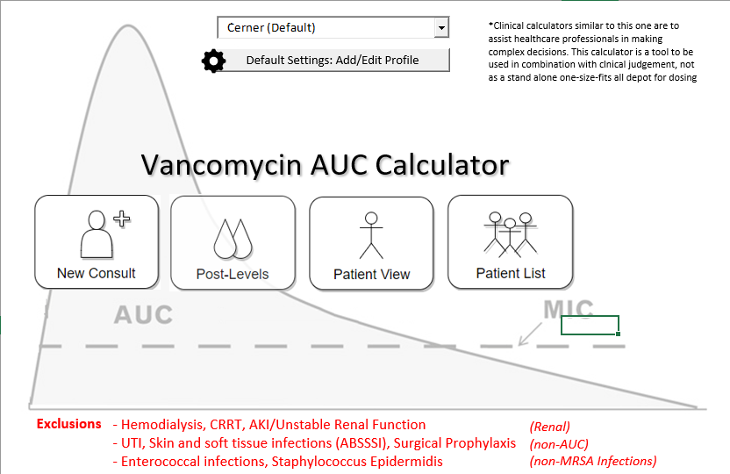

1. **Patient Info:**

* 41 yo Female with MRSA Osteomyelitis
* Wt: 88.9 kg
* Ht: 157 cm

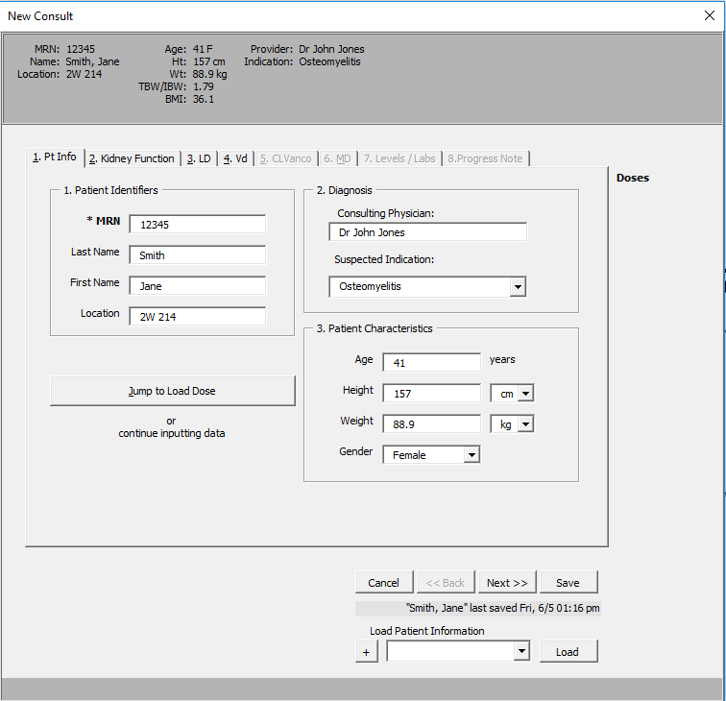

1. Choose the New Consult button
2. Enter the patient information into the calculator and choose Next. Choosing Next will save the information automatically.
3. Select save to add/update information in database
4. Entering the medical record number will allow patient to be identified during future admissions in the database
5. Previously added patients can be identified and loaded in the “Load Patient Information” section
6. **Kidney Function**

* Patient example: This patient has stable renal function with a SCr 0.5 and no concurrent nephrotoxic medications, no amputations
* Enter patient’s current serum creatinine into the calculator
* There is also an option to enter concurrent nephrotoxic agents and amputee status into the calculator. It will then provide a Caution pop-up for more careful monitoring.
* If patient is muscle wasted or cachectic, the SCr can be rounded by selecting “Yes”
* If patient is obese (>120% IBW) the AdjBW can be used to calculate CrCl by selecting “Yes”
* Select “Accept ### ml/min as CrCl”

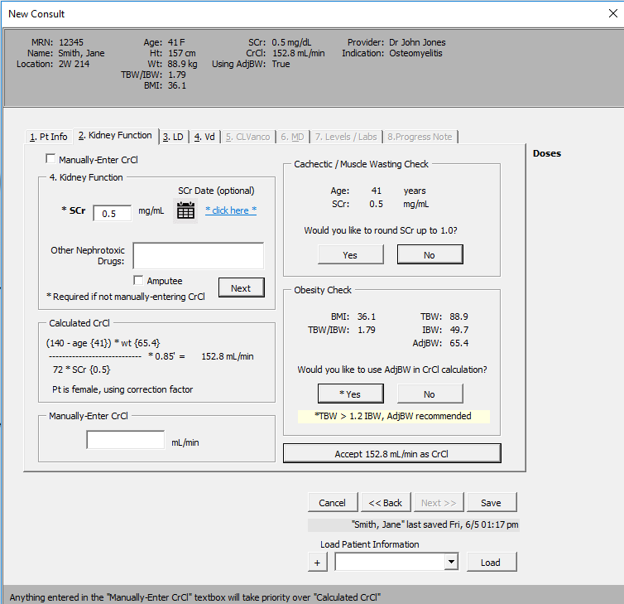

1. **LD – Loading Dose**

* New IDSA Vancomycin Guidelines from March 2020 recommend giving a loading dose for critically ill patients, ICU patients, those that require dialysis or renal replacement therapy. Consider whether patient requires a loading dose and if so, what category they fall into, and select “Calculate Load” or “No Load”.
* Loading dose max will be hospital specific, but according new guidelines may go up to 3000 mg.
* Calculator will estimate what time the loading dose will be given, adjust time based on expectations (consider time to dispense and potential delay from administering other antibiotics before vancomycin)
* Accept loading dose if giving, or hit next. 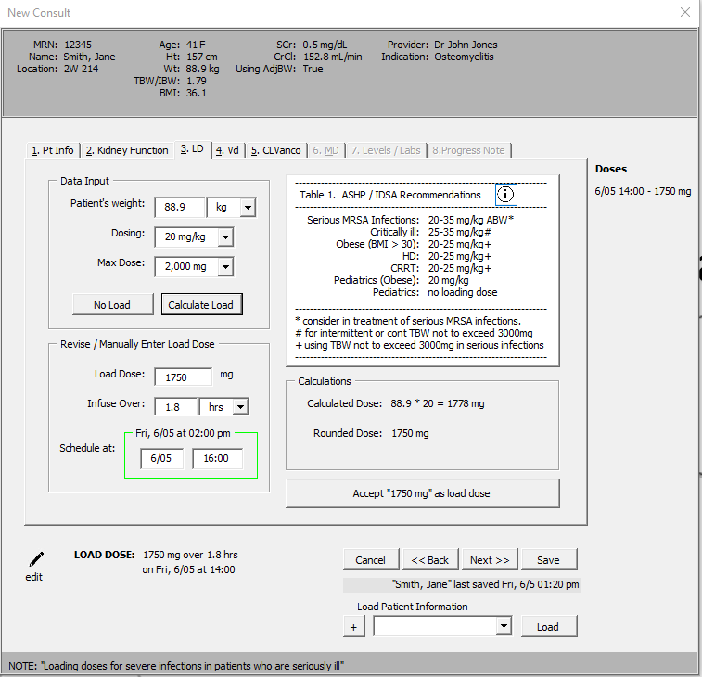

1. **Vd: Volume of distribution**

Select desired Volume of distribution based on Table and patient characteristics and hit Next. Will default to 0.65 Vd.

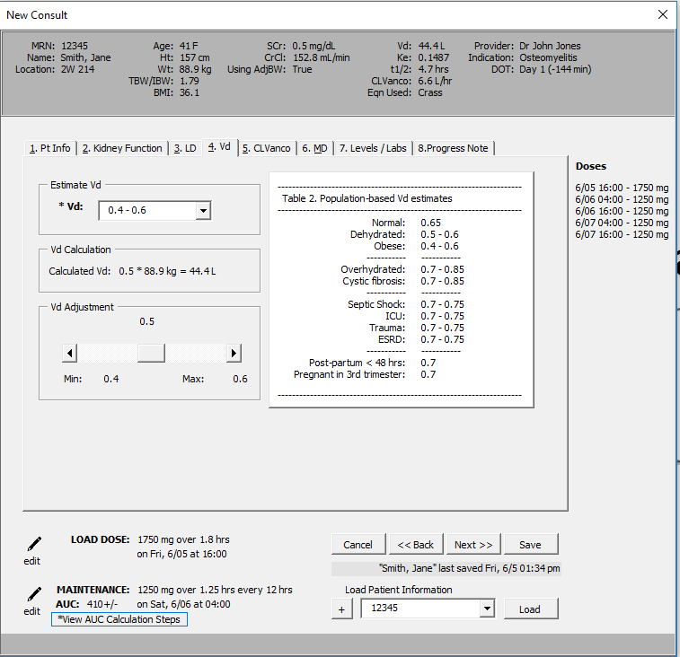

1. **Cl Vanco**

* Select the vancomycin clearance equation to estimate vancomycin clearance based on the patients renal function +/- weight.
* Crass is more appropriate for obese patients. Matze may be used for all others.

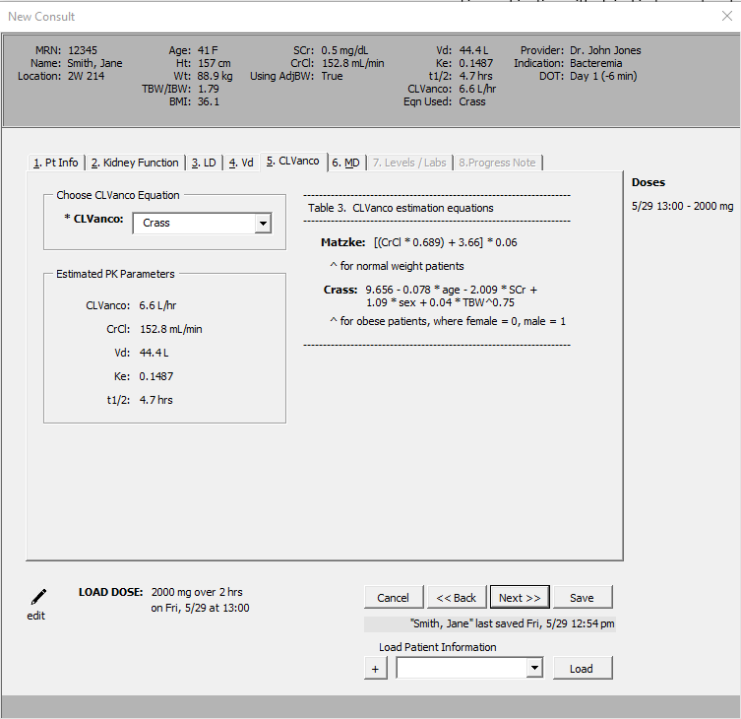

1. **Maintenance Dose Table**

* Potential doses will populate in the table based on a Target AUC24/MIC 400-600
* Boxes will populate with estimated AUC on top and troughs on bottom
* Choose an appropriate dosage regimen based on target AUC24/MIC 400-600 by selecting the box. Keep in mind the troughs may be low, but we are dosing on target AUC.
* The selected dosing regimen will appear, hit next

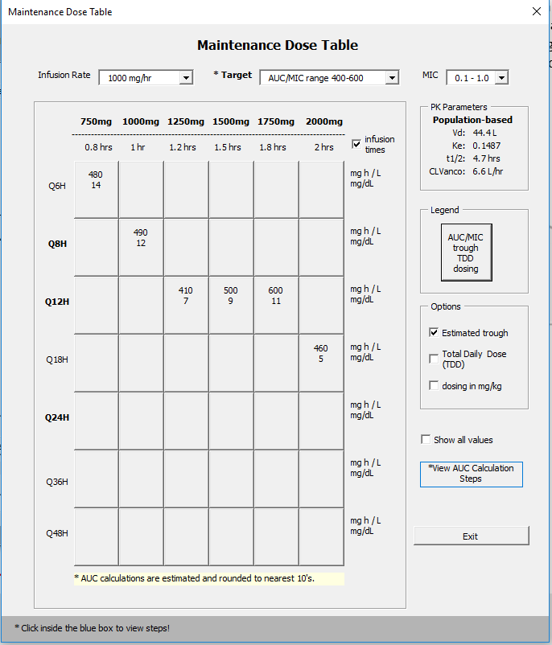

1. **Levels/Labs**

* Under Schedule Labs, the desired time for post dose levels will populate based on when the loading dose was given. They should be collected after the 1st dose or at steady state, depending on the infection severity and patient risk for AKI.
* Hit Next

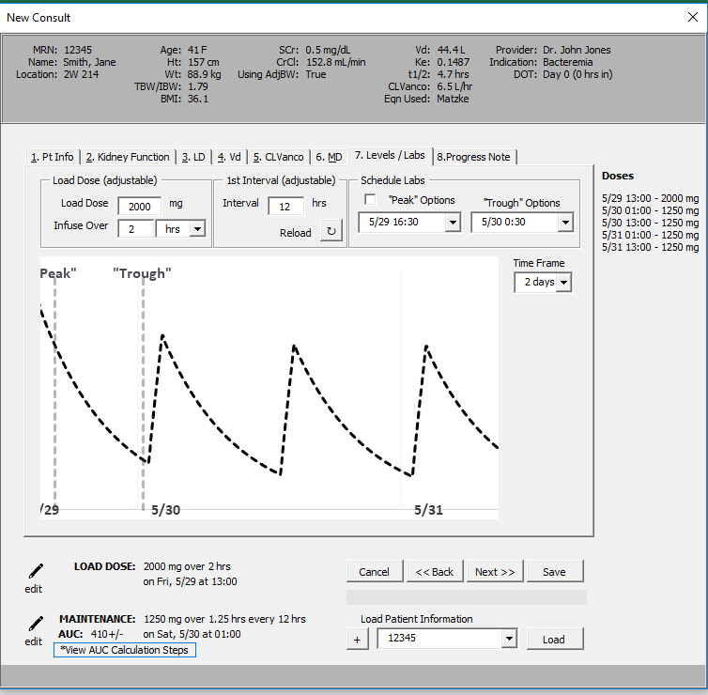

1. **Progress Notes**

* This page will populate with the information that was used to determine the LD (if giving) and MD. It can be copied and pasted into a Cerner Progress Note.
* Hit “Create Monitoring Form”

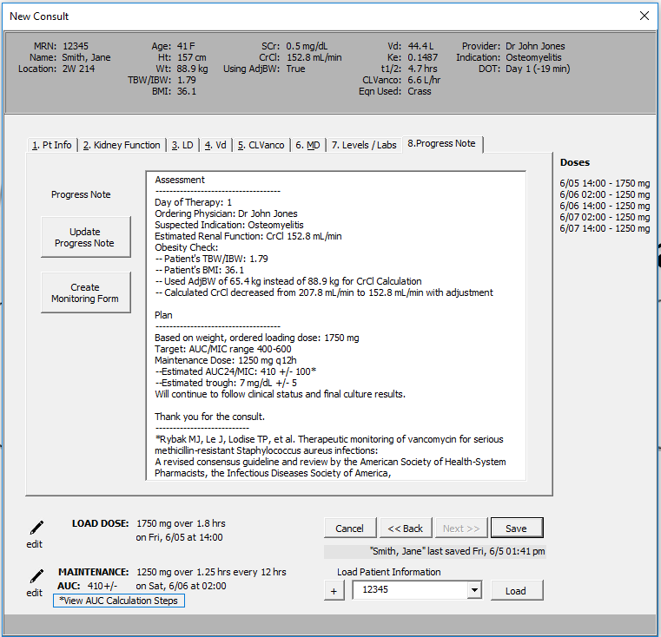

**Calculator Generated Monitoring Form:**

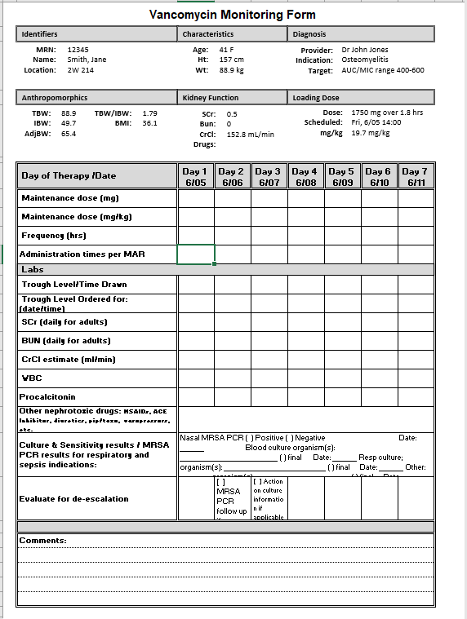

**Two post dose levels:**

* Use “Post-Level” portion of calculator once two post dose levels are available – ideally close to steady state (after 4th dose) and at least 1 half-life apart.



* + - 1. **Search patient and load patient information input from initial empiric dosing or fill in demographic information:**

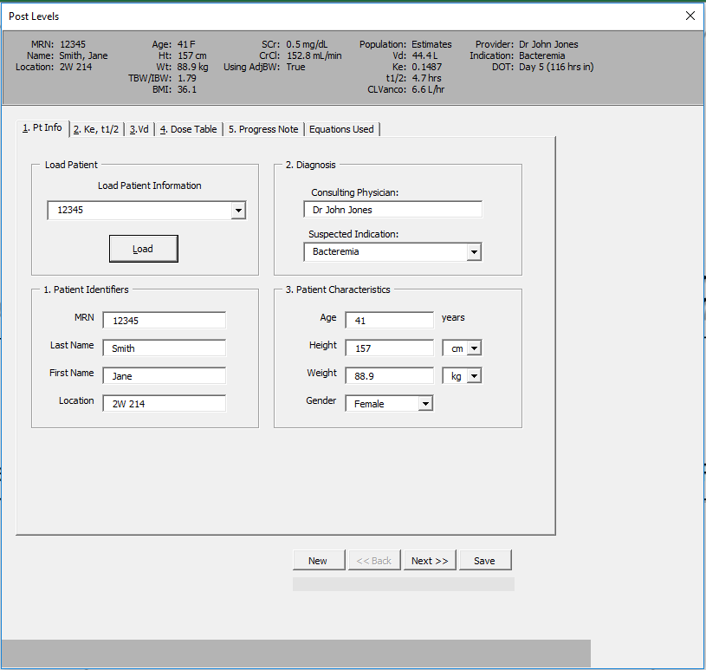

* + - 1. **Post dose level entry – patient specific Ke, t1/2 results**
* Enter post dose levels, ensure times and dates are correct based on when last dose was given
* Hit the “Calculate the Ke, t1/2” and Next
* The green check mark indicates there is at least one t1/2 between the levels

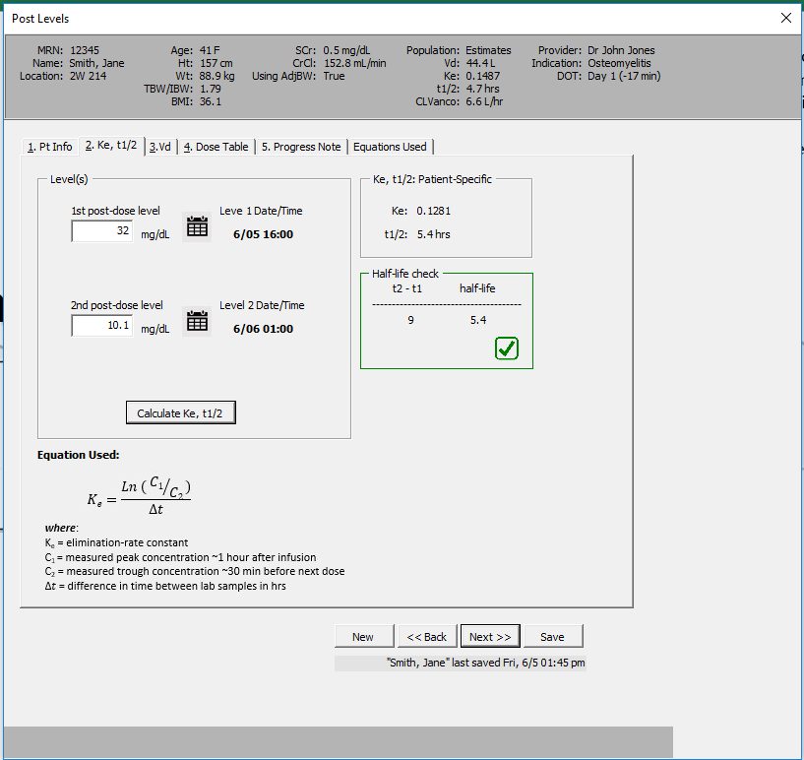

* + - 1. **Volume of Distribution**
* Select Level Strategy: after 1st dose vs steady state
* Enter the dose the patient received, verify the infusion time, and date/time administered. If level is at steady state, enter and verify the dosing interval.
* Hit “Calculate Vd”
* Hit “Next”

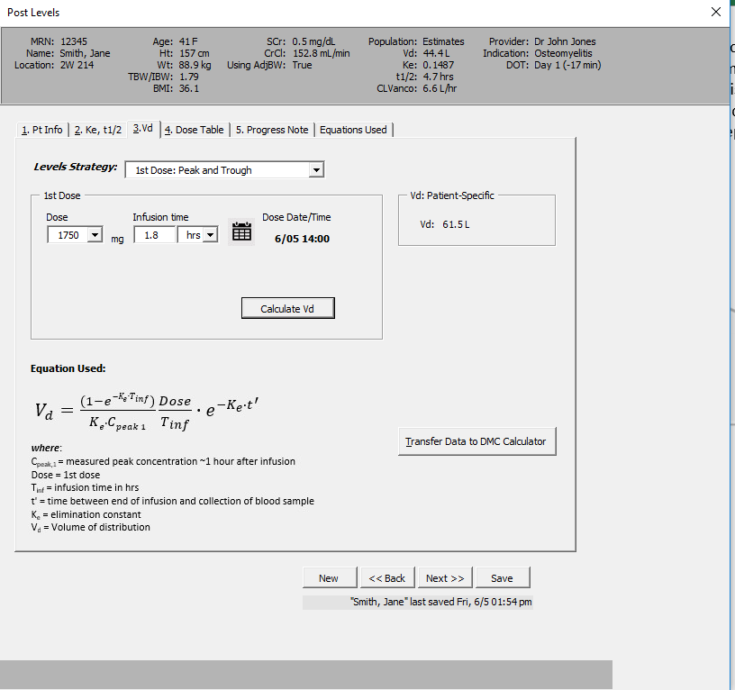

* + - 1. **New Maintenance Dose Table:**
* If necessary, select a new maintenance dose based on the AUC target. Usually the lowest clinically effective AUC dose should be used, along with consideration for more convenient dosing (i.e. avoid q18H, q36H intervals if possible)
* Patient specific PK parameters are presented on the right

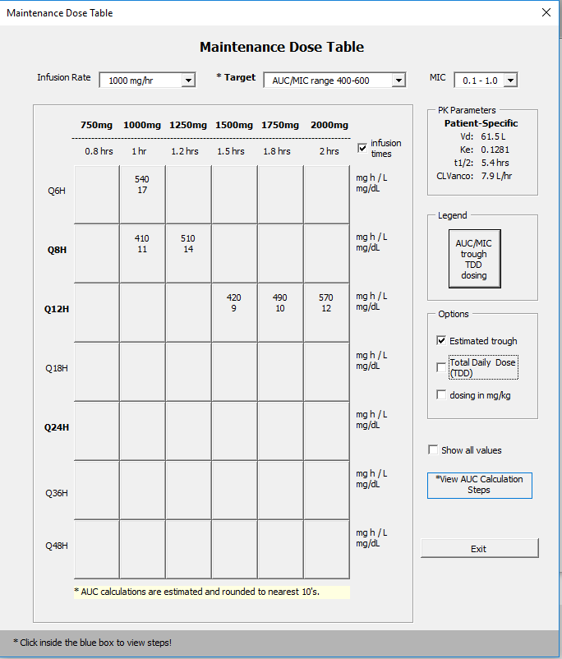

1. **Progress Note Update**

* The progress note is now updated with the patient specific PK parameters and dosage adjustment information.

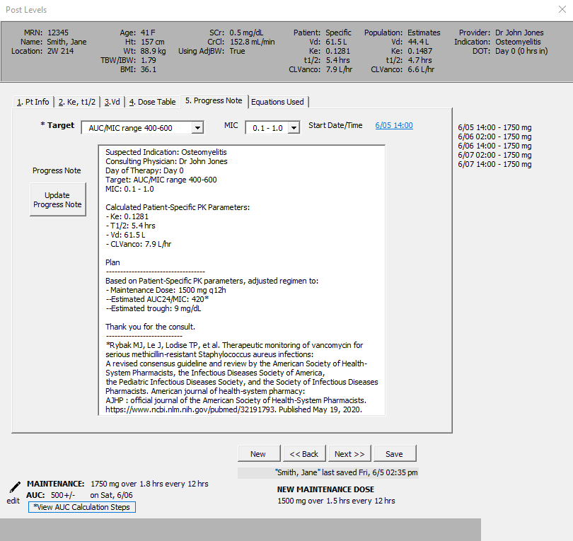

**Patient 2:**

MRN: 123456, Location: 314 (ICU)

Name: Jimmy Dean

Age: 72

Gender: Male

Height/weight: 180.34 cm 102.3 kg measured

SrCr 1.3 – stable

Other medications: Metformin, metoprolol, aspirin, Lisinopril & Pip/tazo

WBC 18,000, temperature 39.5 C

Indication: Pneumonia

Questions:

1. Creatinine Clearance: _______________ ml/min
2. Loading dose:
   1. Patient should receive a loading dose? [ ] Yes [ ] No
   2. Why or why not: _________________________________________________________
   3. If yes, loading dose selected: _______________________________________________
3. Vd selected & why: _____________________________________________________________
4. CL Vanco Equation Selected: ______________________________________________________
5. Maintenance Dose: _____________________________________________________________
6. Schedule post-dose levels after:

[ ] 1st dose why? _________________________________________________________

[ ] 4th dose; why? ________________________________________________________

[ ] Wait and re-evaluate in 24 hours; why? ____________________________________

**Patient 2 *continued:***

Loading dose (2000 mg) administered on 6/5 @ 12:00 (over 2 hours)

1st Post dose level = 31.2 on 6/5 @ 15:00

2nd Post dose level: 30 minutes prior to subsequent dose = 7.8 on 6/6 @ 00:30

Questions:

* + - 1. Patient specific Vd: ___________________L
      2. New maintenance dose: _________ mg Q ____ h
      3. Estimated AUC: ________________

Why did you choose this regimen?

_______________________________________________________________________________________

_______________________________________________________________________________________

_______________________________________________________________________________________

What is the total gram/day? _________________

Does this place the patient at additional risk for nephrotoxicity.

**Patient Case 3:**

Age: 59 years

Gender: Male

Height/weight: 180.34 cm 63.3 kg measured

SrCr 0.8 (4/27/20 0352) stable

WBC 9.31, Afebrile

Indication: Sepsis

Questions:

1. Creatinine Clearance: _______________ ml/min
2. Loading dose:
   1. Patient should receive a loading dose? [ ] Yes [ ] No
   2. Why or why not: _________________________________________________________
   3. If yes, loading dose selected: _______________________________________________
3. Vd selected & why: _____________________________________________________________
4. CL Vanco Equation Selected: ______________________________________________________
5. Maintenance Dose: _____________________________________________________________
6. Schedule post-dose levels after:

[ ] 1st dose why? _________________________________________________________

[ ] 4th dose; why? ________________________________________________________

[ ] Wait and re-evaluate in 24 hours; why? ____________________________________

**Patient 3 *continued*:**

Maintenance Regimen Selected (no LD given): Vancomycin 1 gm q12h, 1 dose at 1734 on 2/10 over 1 hr

"Peak": 2/12 @ 2001 - 24.3

"Trough": 2/12 @ 0510 - 15.9

Questions:

1. Patient specific Vd: ___________________L
2. New maintenance dose: _________ mg Q ____ h
3. Estimated AUC: ________________

Why did you choose this regimen?

_______________________________________________________________________________________

_______________________________________________________________________________________

_______________________________________________________________________________________

What is the total gram/day? _________________

Does this place the patient at additional risk for nephrotoxicity.

How would you treat this patient differently if the vancomycin was indicated for cellulitis?

_______________________________________________________________________________________

**References:**

1. Rybak MR, Le J, Lodise TP et al. Therapeutic monitoring of vancomycin for serious methicillin-resistant Staphylococcus aureus infections: A revised consensus guideline and review by the American Society of Health-System Pharmacists, the Infectious Diseases Society of America, the Pediatric Infectious Diseases Society, and the Society of Infectious Diseases Pharmacists. Am J Health-Syst Pharm. 19 Mar 2020;  <https://doi.org/10.1093/ajhp/zxaa036>.
2. Khuu T, Bagdasarian G, Leung J, et al. Estimating aminoglycoside clearance and creatinine clearance in underweight patients. Am J Health Syst Pharm. 2010;67(4):274‐279. doi:10.2146/ajhp090251
3. Winter MA, Guhr KN, Berg GM. Impact of various body weights and serum creatinine concentrations on the bias and accuracy of the Cockcroft-Gault equation. Pharmacotherapy. 2012; 32(7):604-612.
4. Infectious Diseases Society of America. Clinical practice guideline for the diagnosis and treatment of diabetic foot infections. Clin Infect Dis 2012;54:132-73.
5. Liu C, Bayer A, Cosgrove SE, et al. Practice guidelines by the Infectious Diseases Society of America for the treatment of methicillin-resistant Staphylococcus aureus infections in adults and children. Clin Infect Dis 2011;52:1-38.
6. Metlay JP, Waterer GW, Long AC, Anzueto A, Brozek J, Crothers K, et al. Diagnosis and Treatment of Adults with Community-acquired Pneumonia. An Official Clinical Practice Guideline of the American Thoracic Society and Infectious Diseases Society of America. Am J Respir Crit Care Med. 2019 Oct 1. 200 (7):e45-e67. <https://www.atsjournals.org/doi/10.1164/rccm.201908-1581ST#_i6>
7. Stevens DL, Bisno AL, Chambers HF, et al. Practice guidelines for the diagnosis and management of skin and soft tissue infections: 2014 update by the Infectious Diseases Society of America. Clin Infect Dis 2014;59:e10-59.
8. Early Oral Switch to Linezolid for Low-risk Patients With Staphylococcus aureus Bloodstream Infections: A Propensity-matched Cohort Study. AU Willekens R, Puig-Asensio M, Ruiz-Camps I, Larrosa MN, González-López JJ, Rodríguez-Pardo D, Fernández-Hidalgo N, Pigrau C, Almirante B SO Clin Infect Dis. 2019;69(3):381.
9. Schweizer ML, Furuno JP, Harris AD et al. Comparative effectiveness of nafcillin or cefazolin versus vancomycin in methicillin-susceptible Staphylococcus aureus bacteremia. BMC Infect Dis. 2011; 11: 279.
10. Detroit Medical Center. “Vancomycin Dosing in Adults- Clinical Guidelines” Jan 2015 and https://pharmacy.ufl.edu/files/2013/01/5127-28-equations.pdf. Accessed 29 April 20.
11. Stanford Health Care. SHC Vancomycin Dosing Guide. Revised 9/2018. Accessed 29 April 20. Available from <http://med.stanford.edu/bugsanddrugs/guidebook/_jcr_content/main/panel_builder_584648957/panel_0/download_2105810811/file.res/SHC%20Vancomycin%20Dosing%20Guide.pdf>.
12. University of Nebraska Medical Center. “Renal Dosing Adjustment Guidelines for Antimicrobials”. Available from <https://www.nebraskamed.com/sites/default/files/documents/for-providers/asp/antimicrobial-renal-dosing-guidelines.pdf>.
13. Li PK, Szeto CC, Piraino B, et al. ISPD Peritonitis Recommendations: 2016 Update on Prevention and Treatment. Peritoneal Dialysis International 2016;35:481-508.